Understanding Trump Voters

Americans voted in record numbers in the 2020 United States presidential election. The highest voter turnout since 1980 was fueled by broad ideological differences, partisan preferences, and anger towards the incumbent. Political groups are individuals who are actively involved in politics, and often form committees to privately raise money to fund political campaigns. It is imperative that these groups understand where to focus their efforts to increase participation among supporters. To accurately determine what kind of people voted for Trump in 2020, we turn to the American National Election Studies (ANES). The academically-run ANES designs nationally representative cross-sectional surveys of voters in the United States. If a political group approached us to inform them about Trump voters, we would use available data to operationalize metrics and identify frequency, distributions and correlations of variables to provide evidence for our conclusions.

Data and Methods

Initially, we were presented with a file that contains more than 8000 voter records across more than 50 columns

We inspected the file for missing values and observed that out of the more than 8000 records, there were 1550 records that had fully populated values

Because the focus of our analysis is on Trump voters, we conditionally formatted ‘whovoted’ column for 2 (Trump voters)

With this approach, we are left with 642 voter records specific to Trump

After finally cleaning up our data, we performed exploratory data analysis. Our results are represented in the Descriptive Statistics section

Descriptive Statistics

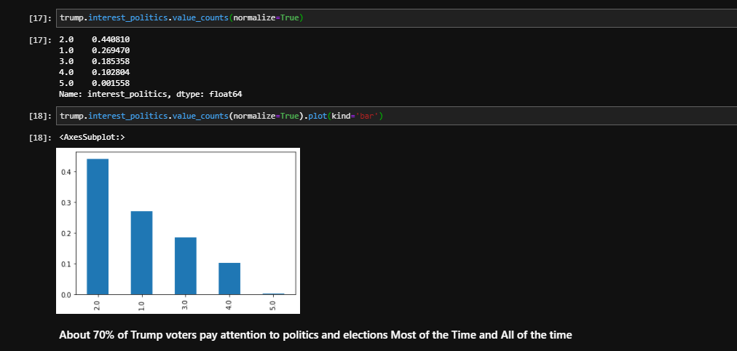

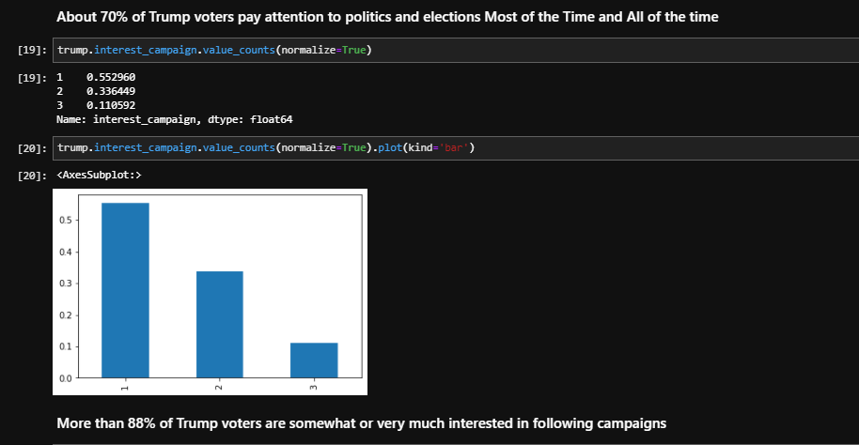

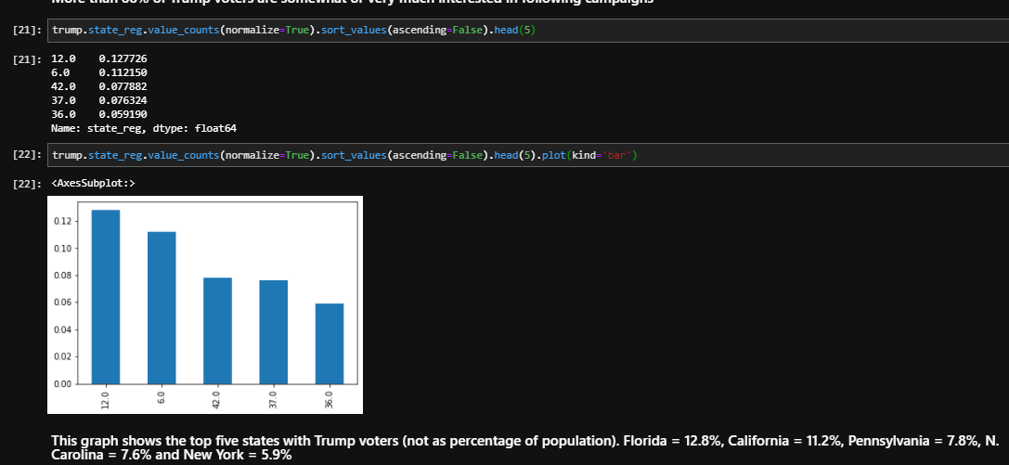

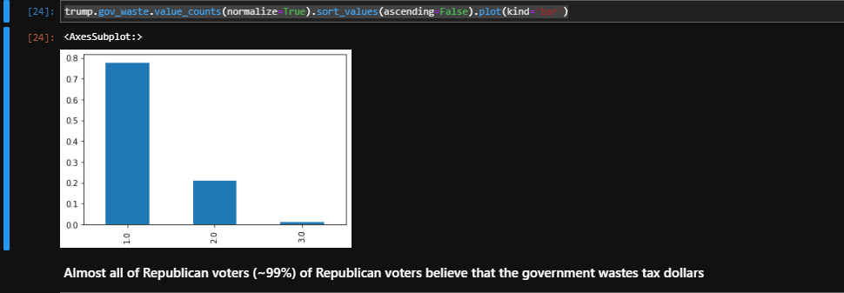

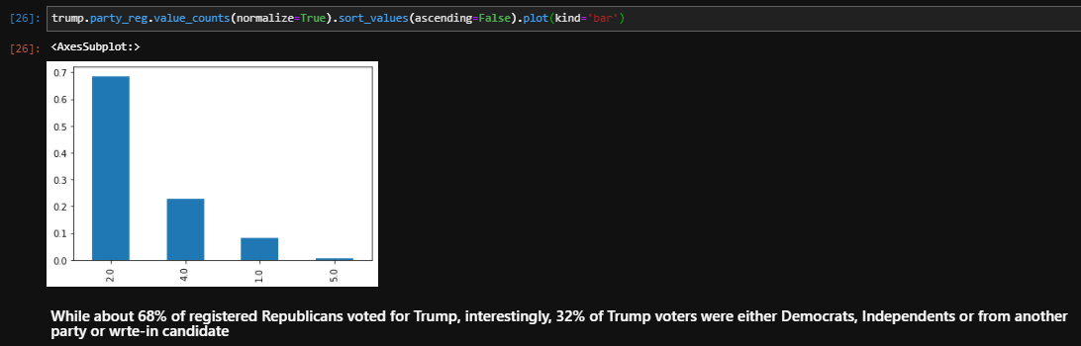

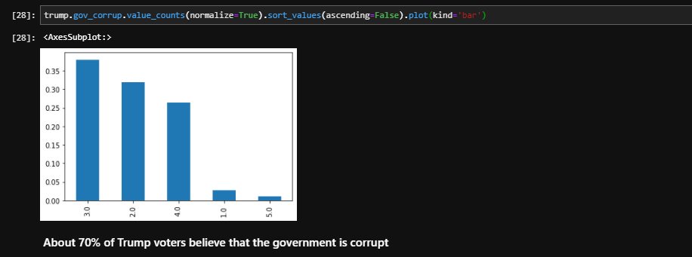

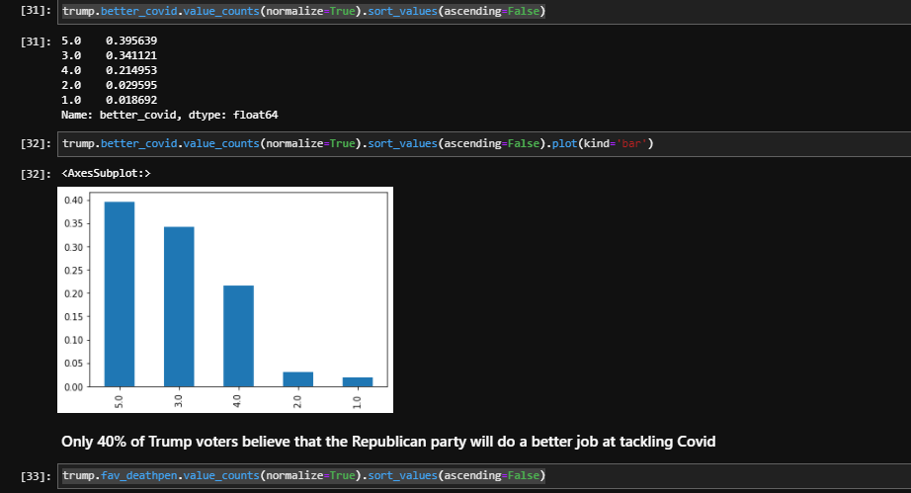

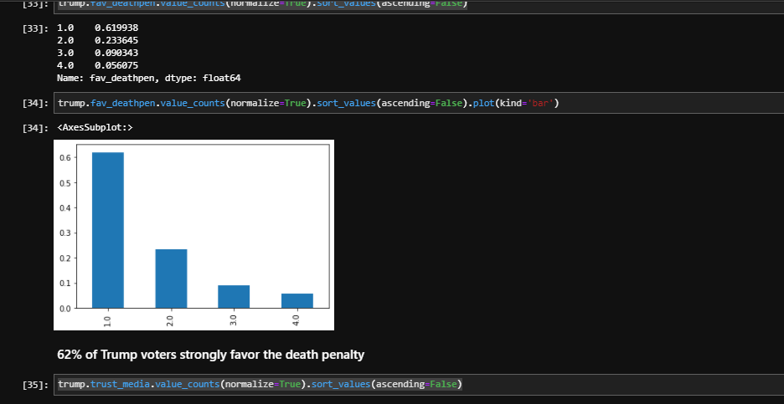

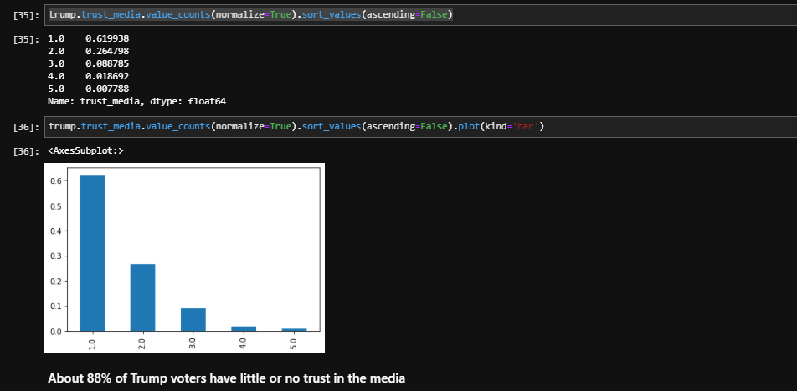

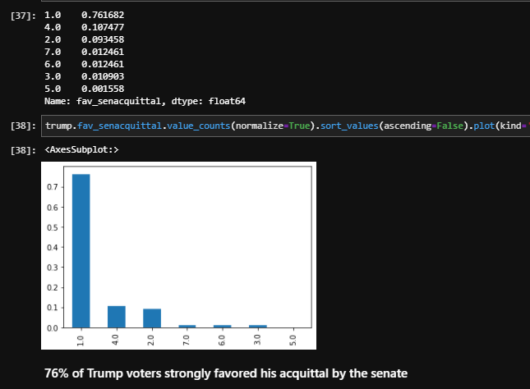

Regression Analysis

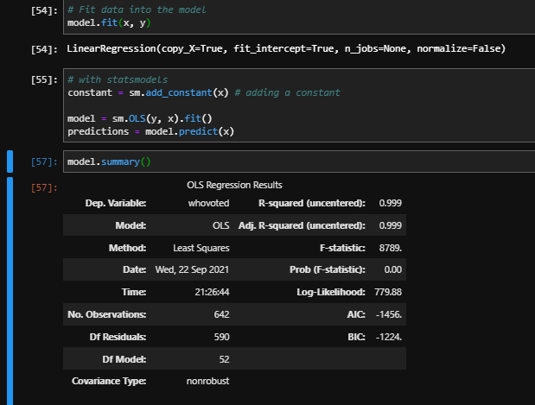

Interpretation and Discussion

The most important result of our analysis is that our stereotypes about Trump voters are not accurate We have a lot in common than e know

Our analysis showed that off all of the issues presented, covid provid belief tended be a very important issue of Trump voters. Of all of the respondents, households impacted (not impacted) by covid is explained is reflected in 13% of the y varable